DLD-1 | Caco2
22.06.2026 green team: Line, Lars, Andreas  DLD1  Experiment 1: NaBu & Resv dose response  DLD only  Use NaBu concentration of 1mM  Seed 2 x 24 well-plate with 25.000 cell/ml.  1 ml/well.  Pre-wet wells with 0.5 ml McCoy before adding 1 ml 25’000 cell/ml  Mastermix of 55 ml. (1’375’000 cells  McCoy medium) | 22.06.2026 green team: Line, Lars, Andreas  CaCo-2  Passage 300’000 cells  Experiment 1: NaBu dose response  No Caco for exp 1 week 2 dose response
Mastermix’s of DLD:  Exp1: 55 ml with 1.375.000 cells  Exp 2a: 36 ml 2.100.000 cells  Exp 2b: 10 ml with 500.000 cells  Exp 3: 30 ml with 1’500’000 cells  Exp 4: -  Seed 500’000 also for new passage | Mastermix’s of Caco2:  Exp1: -  Exp 2a: -  Exp 2b: 10 ml with 500.000 cells  Exp 3: -  Exp 4: -  Seed also for new passage 300.000
22.06.2026 green team: Line, Lars, Andreas  DLD-1:  Seed for experimental 2A: cell cycle analysis  Seed 3 x T75 flask with 700.000 cells in each flask, total of 12 ml/flask. | 22.06.2026 green team: Line Lars Andreas  CaCo-2
22.06.2026 green team: Line, Lars, Andreas  DLD-1:  Experiment 2b:  Hoechst 33342 / Alamar Blue 96 well assays  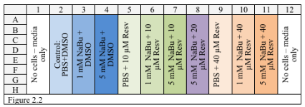  Seed one 96 well plate with 10.000 DLD-1 cells pr well. Volume of 200 uL pr well.  Mastermix:  10ml with 500.000 cells | 22.06.2026 green team: Line, Lars, Andreas  CaCo-2:  Experiment 2b:  Hoechst 33342 / Alamar Blue 96 well assays  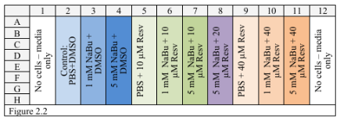  Seed one 96 well plate with 10.000 Caco-2 cells pr well. Volume of 200 uL  Mastermix:  10ml with 500.000 cells
22.06.2026 green team: Line, Lars, Andreas  DLD1:  Experiment 3:  Seed for luciferase assay  200.000 cells/well in a volume of 4 ml/well.  6 wells -> 1’200’000 cells in 24 ml  Make mastermix of 30 ml with 1’500’000 cells | 22.06.2026 green team: Line, Lars, Andreas  CaCo2:  Experiment 3:  Transfection and luciferase assay  Tag prøver fra fredag, 20 ul ud fra hver af 16 brønde hver dag, put dem i 96 well plate, frys ned, måle på torsdag  i.e. 64 wells  Put de 16 wells  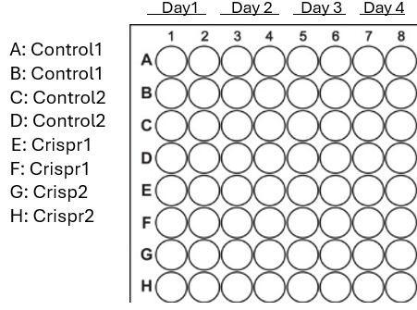
22.06.2026 green team: Line, Lars, Andreas
CaCo-2
Experiment 4:
Fluorescent imaging and staining:
- Inspect the cells in the microscope. Use phase contrast 10x or 20x
- 2. Remove all medium and quickly add 0.5mL fixative (in fume hood, 10% formalin) and incubate for 20 min at room temperature.
- 3. Remove the fixative and wash three times with PBS for 5 min. Discard fixative appropriately.
Cover petri dishes with tinfoil frem now on!

Stain whith Rhodamin-Phalloidin:
- Mix in an Eppendorf tube 1 µL Rhodamine-Phalloidin to 1 mL 1% BSA in PBS, add 100 µL per cover slip. Incubate for 30 min at room temperature.
-If the solution is prepared in advance, seal the Eppendorf tube with tinfoil and keep it on ice.
- Wash the cover slips 2 x 5 min in PBS.
- Remove cover slips from the petri dish with scalpel and mount them on microscope slides with a drop of mounting media between the slide and cell side of the cover slips.
- Allow mounting media to cure overnight (minimum 12 hours) at room temperature. Seal the edge of the cover slip with nail polish, brand and color is optional. Let the samples dry in petri dishes covered with tinfoil and store them in the refrigerator.
-The samples may be kept in the refrigerator for several days. If there is a need for longer storage, this may be done at -20°C.

